Project Title

AUTOMATED NETWORK REQUEST MANAGEMENT SYSTEM

Name : Avala Praveena
College : Sri Vasavi Engineering College
Email : 23A81A0571@sves.org.in

PROJECT OVERVIEW
The Automated Network Request Management in ServiceNow project focuses on simplifying and accelerating the handling of network-related service requests. The solution uses ServiceNow's Service Catalog, custom tables, UI Policies, Catalog Client Scripts, Flow Designer, approval actions, and email notifications to automate the request management process.
End users can submit network requests through a self-service catalog form. The system captures the required requester and network-related information, validates the submitted data, and stores the request details in a structured custom table. After submission, the request is processed through an automated approval flow. Based on the approval result, the request record is updated and appropriate email notifications are generated.
By reducing manual processing and providing a structured request and approval workflow, the system improves transparency, consistency, and efficiency in network request management.
TABLE OF CONTENTS
- Introduction
- Project Objectives
- Key Features
- ServiceNow Developer Setup
- Project Implementation in ServiceNow
- Field Validation and Automation
- Flow Designer and Approval Workflow
- Data Handling and Custom Table
- Access Control and Security
- Testing and QA
- Troubleshooting
- Screenshots of Output
- Project Demo
- Future Enhancements
- Conclusion
1. INTRODUCTION
Modern enterprises rely heavily on reliable network services to support their day-to-day operations. As organizations grow, the number of network-related service requests also increases. These requests may include connectivity requirements, existing network service changes, and other network support activities.
Traditional manual request handling can result in delays, incomplete information, repeated communication, and limited visibility into request status. To address these challenges, the Automated Network Request Management System provides a structured and automated approach using the ServiceNow platform.
The system allows end users to submit requests through a ServiceNow Service Catalog form. The submitted information is captured through catalog variables and stored in a custom Database Tables table. ServiceNow Flow Designer is then used to automate record creation, approval processing, status updates, and email notifications.
The solution provides a complete request lifecycle from request submission to approval and notification, while reducing repetitive administrative activities and improving transparency for both requesters and IT teams.
2. PROJECT OBJECTIVES
The primary objective of this project is to design and implement an automated solution for managing network-related service requests within ServiceNow.
The major objectives are:
- To provide a user-friendly ServiceNow Service Catalog for submitting network requests.
- To capture requester and network-related information through structured catalog variables.
- To reduce incomplete submissions through appropriate field validation.
- To automatically populate relevant requester information where applicable.
- To store submitted request information in a structured custom table.
- To automate the approval process using ServiceNow Flow Designer.
- To update request records according to the approval outcome.
- To send automated email notifications during the request lifecycle.
- To provide better visibility and traceability of requests.
- To implement appropriate access controls for the custom application data.
- To test the complete request, approval, and notification lifecycle.
3. KEY FEATURES
The major features implemented in the project include:
3.1 Service Catalog
A custom Network Request catalog item is provided through the ServiceNow Service Portal. Users can submit their network-related requirements through a structured form.
3.2 Requester Information
The Requester Information variable set captures relevant requester details such as user information, email, and phone number.
3.3 Dynamic Form Behaviour
UI Policies and Catalog Client Scripts are used where required to control form behaviour and dynamically handle information displayed or populated on the catalog form.
3.4 Field Validation
Important fields can be configured as mandatory to reduce incomplete request submissions and maintain data quality.
3.5 Custom Database Table
Submitted catalog information is mapped to the custom Database Tables table (u_database_tables) for structured storage and further processing.
3.6 Automated Flow
ServiceNow Flow Designer automates the request lifecycle. The flow retrieves catalog variables, creates a custom table record, sends notifications, requests approval, evaluates the approval result, and updates the request accordingly.
3.7 Approval Workflow
The system includes an approval stage before the request can proceed to the next stage of processing. The approval outcome is evaluated by the flow.
3.8 Email Notifications
Automated email notifications are used to communicate important request events, such as request creation and approval-related updates.
3.9 Access Control
Access Control Lists (ACLs) are configured for the custom table to control operations such as create, read, write, and delete according to the configured roles.
3.10 Request Tracking
The custom table stores request information and approval status, allowing administrators and authorized users to track the progress of submitted requests.
4. SERVICENOW DEVELOPER SETUP
The project was developed and tested using a ServiceNow Personal Developer Instance (PDI).
The development environment was used to configure:
- Service Catalog
- Catalog Variables
- Variable Sets
- UI Policies
- Catalog Client Scripts
- Custom Tables
- Access Control Lists
- Flow Designer
- Approval Actions
- Email Notifications
- Service Portal
The project was implemented within the ServiceNow development environment and tested using sample request submissions.
5. PROJECT IMPLEMENTATION IN SERVICENOW
The implementation was carried out in multiple stages:
Phase 1 – Catalog Creation
A Service Catalog item named Network Request was created to allow users to submit network-related requests.
Phase 2 – Form Configuration
Catalog variables were configured to collect the required request information, including:
- Requested For
- Mobile Number
- Type of Connection
- Existing ID
- Total Amount
- Mode of Payment
- Address
A Requester Information variable set was also configured for requester-related information.
Phase 3 – Custom Table
A custom table named Database Tables was created to store the submitted request information.
The table contains fields for important request information such as:
- Database Number
- Requested For
- Mobile Number
- Type of Connection
- Existing ID
- Total Amount
- Mode of Payment
- Address
- Approval Status
- Assigned To
Phase 4 – Flow Designer
A Flow Designer flow named Network Request was configured to automate the request lifecycle.
The flow performs the following major operations:
Service Catalog Request → Get Catalog Variables → Create Database Tables Record → Send Email → Ask for Approval → Check Approval Result → Update Record
Phase 5 – Testing
The complete workflow was tested using sample catalog submissions. Request creation, record generation, approval processing, email notification, and request status updates were verified.
IMPLEMENTATION
Phase:2
Step:1.1 Table Creation
Navigate to: System Definition > Tables.
Click New to create a new table.
Fill in Table Information:
Label: Database Tables
Name: u_database_tables
Click Submit to create the table.
Step:1.2 Create Fields in Database Table
Navigate to All → System Definition → Tables.
Search for Database Tables in the table list.
Open the Database Tables table.
Create fields using Insert new record at table columns
Create required fields which are shown in the img
Verify the newly created fields by opening a Database tables records.
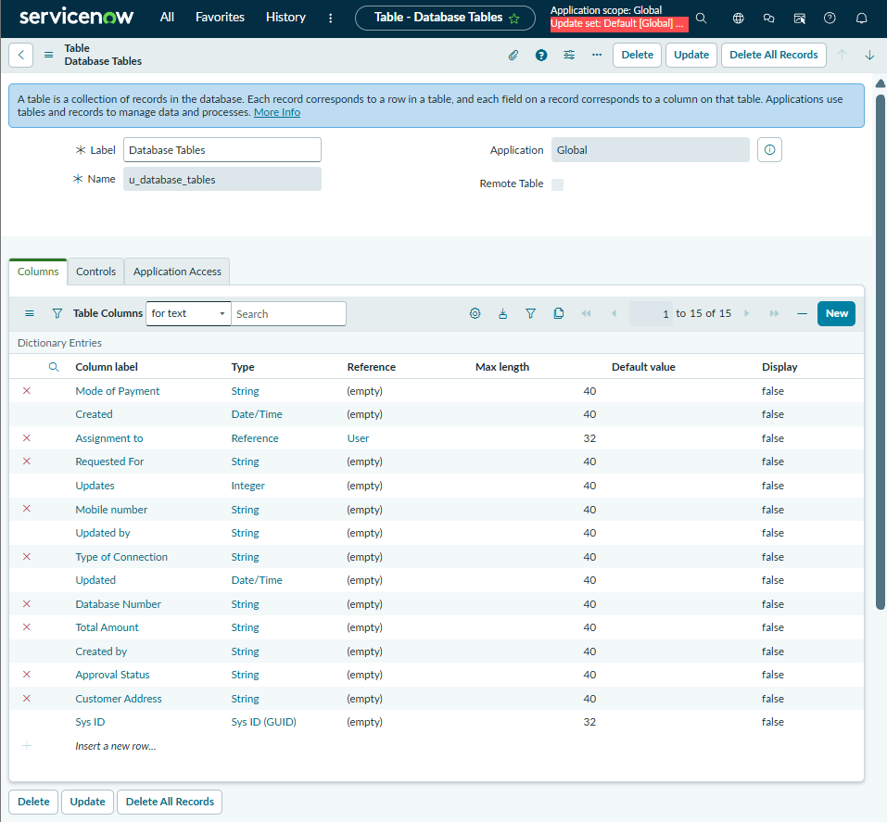
Step: 2.1 Creation of Approval Request on Network Database Table
Activity 1: Creation of Related List
Navigate to System Definition > Relationships.
Click New to create a new relationship.
Fill in the following details:
Name: Approval Request
Applies to Table : Database table
Queries from Table : sysapprovals table.
Active: Make sure it's set to True.
Save the relationship.
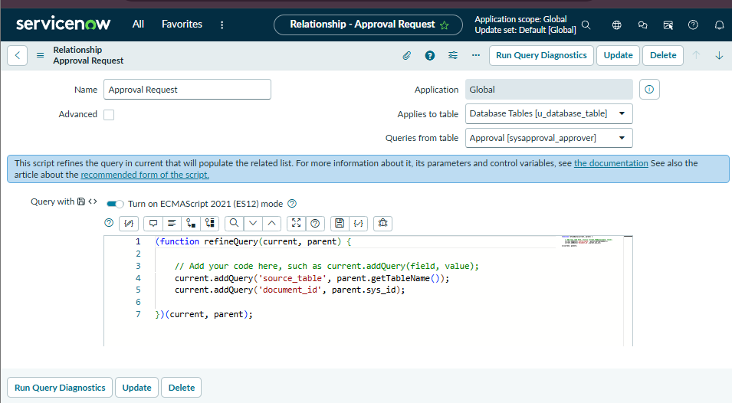
Activity 2: Adding Related List to the Table
Through tables->Database tables -> in related links click Show List -> create new ->fill the fields as shown in fig .
Now open that just now created record.
Add a Related List widget to the form.
Select the Related List you want to show
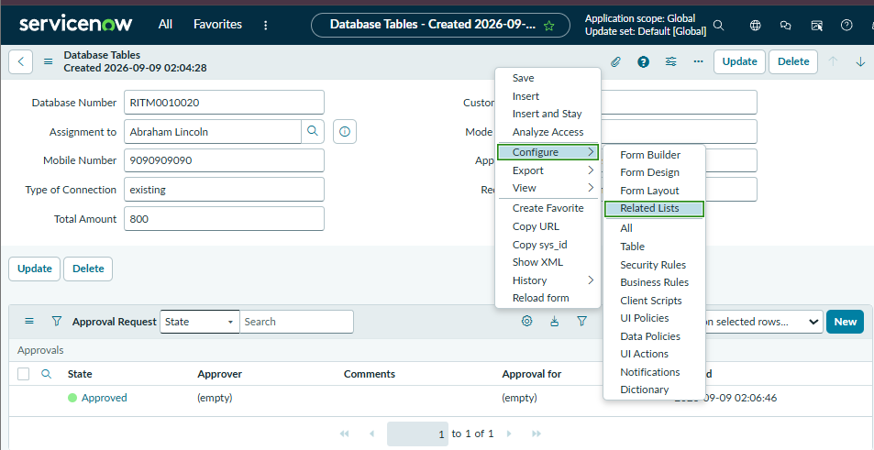
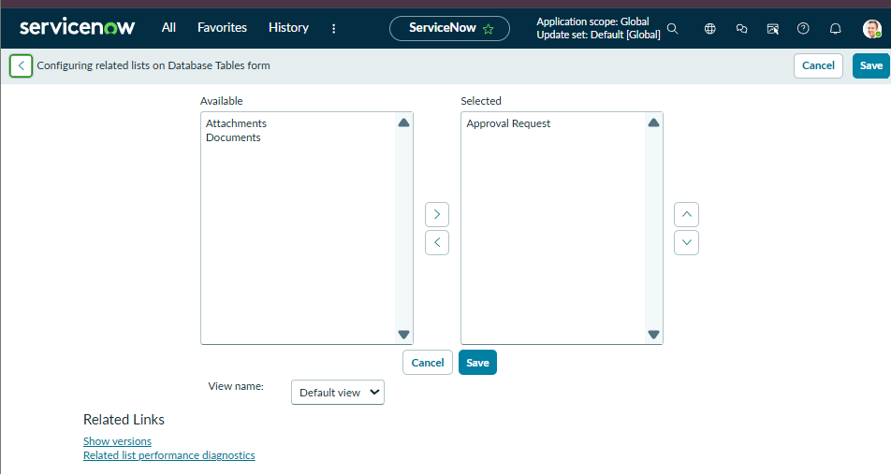
Phase-3
Interface Design
Activity 1: Creation of Service Catalog
medium
Description
Navigate to Application navigator
Click on All >> search for Service Catalog
Under Service Catalog>> Maintain items
Click on New
Fill the details >> Name– Network Request
Select Catalog>> Service Catalog
Select Category>> Networks and Connectivity / Network Standard changes
Fill the Short Description as Network request Management
Click on Save.
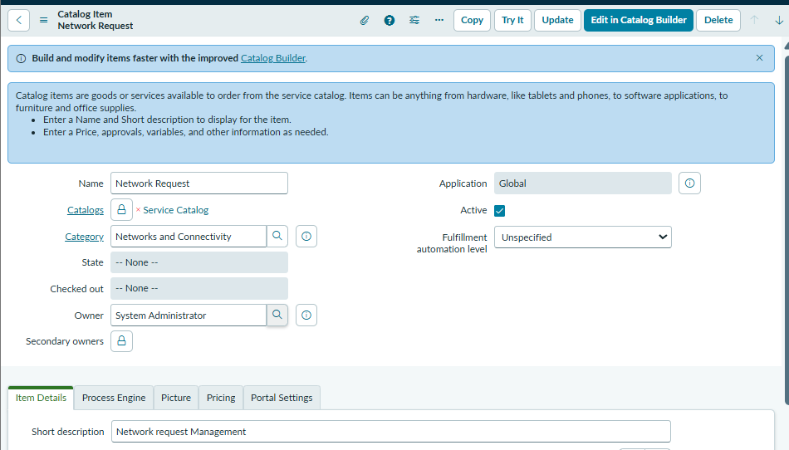
Open the catalog item just created.
Scroll down to the Variables related list and click New to create form fields.
Select Variables type as Single, Multi line text, reference, choices etc as per requirement
Catalog item– Network Request
Order–100,200,300,,,,
Question– provide the variable label
Name–provide the variables name(used for scripting)
Tooltip– this will appear when cursor overed on the field
Example text – this will suggest what we need to enter on the field.
Mandatory, Read-Only– need to configure on demand
Auto populate– need to select dependent variable, apply dot walking to get selected value.
Click on Save or Submit.
I created 10 variables 7 are enough
Note : For multiple choices ,Default was new ,UPI ,Laptop etc based on fields
Don’t create choices which are add in to default tab.
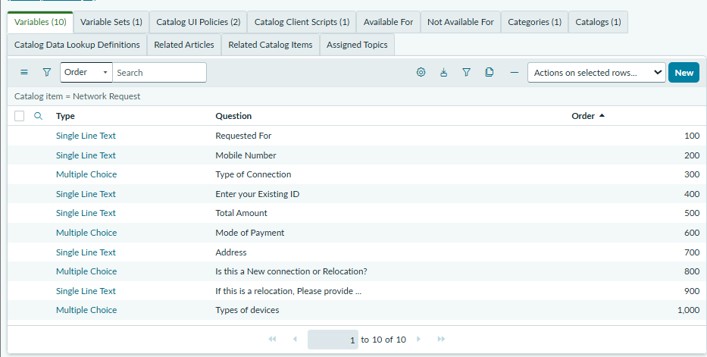
Activity 4: Variable Set Configuration
Description
To enhance form usability create a Variable set
Navigate to the Variable Sets with in the Catalog Item.
Follow the same procedure as we used for Variables Creation, for the variable set as well.
Apply variable sets to the catalog item.
Variables Details
S.NO | Variable Name | Type | Reference / Configuration
1 | Opened on behalf of | Reference | Reference → User [sys_user] table
2 | Email ID | Single Line Text | Auto-populate from Opened on behalf of
3 | User Name | Single Line Text | Auto-populate from Opened on behalf of
4 | Phone Number | Single Line Text | Auto-populate from Opened on behalf of
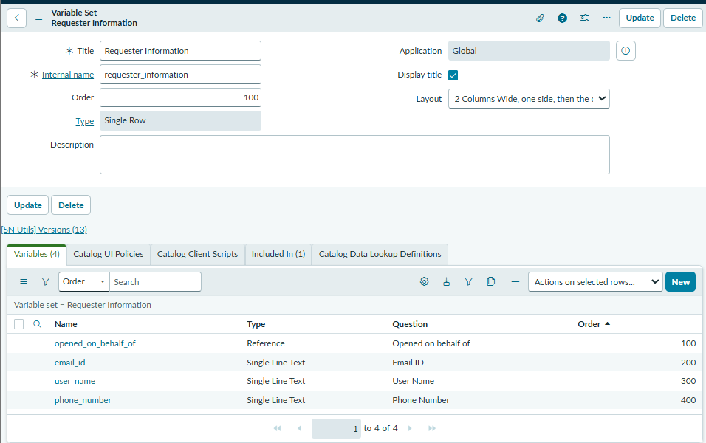
NOTE : Follow the same procedure to create all four variables and for the auto populate the vales follow the below pictures
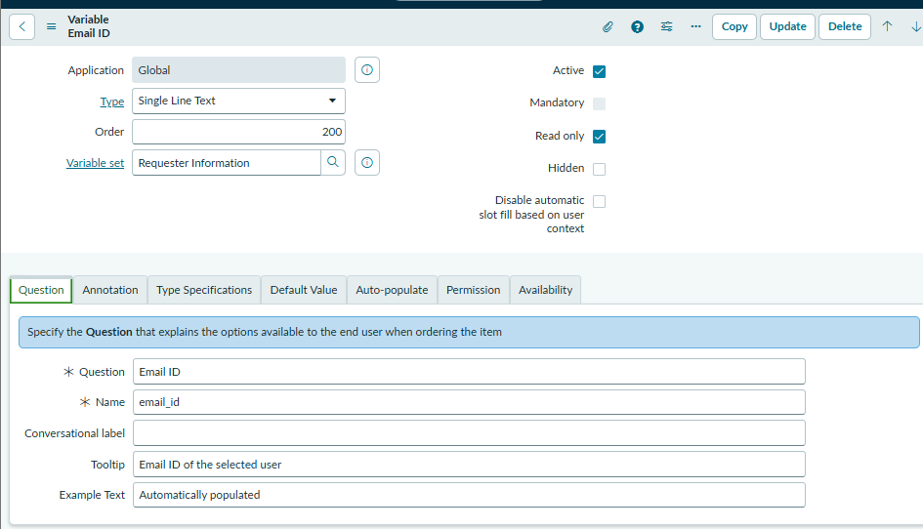
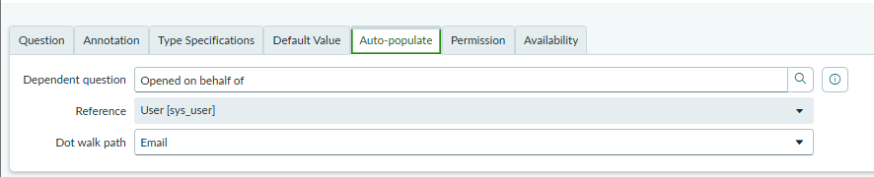
Note: Follow the same procedure to auto populate values for all other variables
Step :3.3 UI Policy
Procedure
Navigate to Maintain Items
Open Network Request item
In related list, we have Catalog UI policy
Click on New button to configure New UI policy
Select Applies to as Catalog item
Select catalog item as Network Request
Provide short description, if required
Apply condition>> types of Connection is Existing
Click on save, after saving the form will get UI policy actions in the related list
Click on New button to configure new UI Policy action, and select the variable which we want to display on condition
Make Visible True as per our requirement
Update the UI Policy and Test the same on Catalog form.
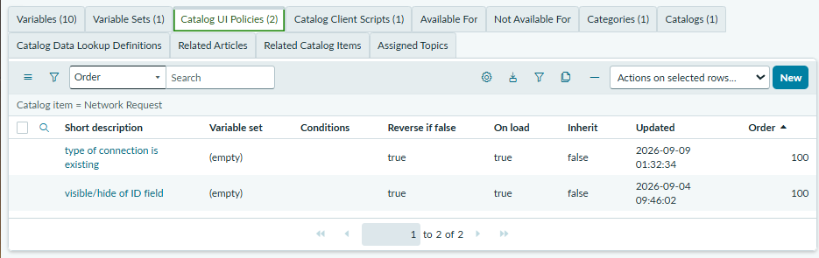
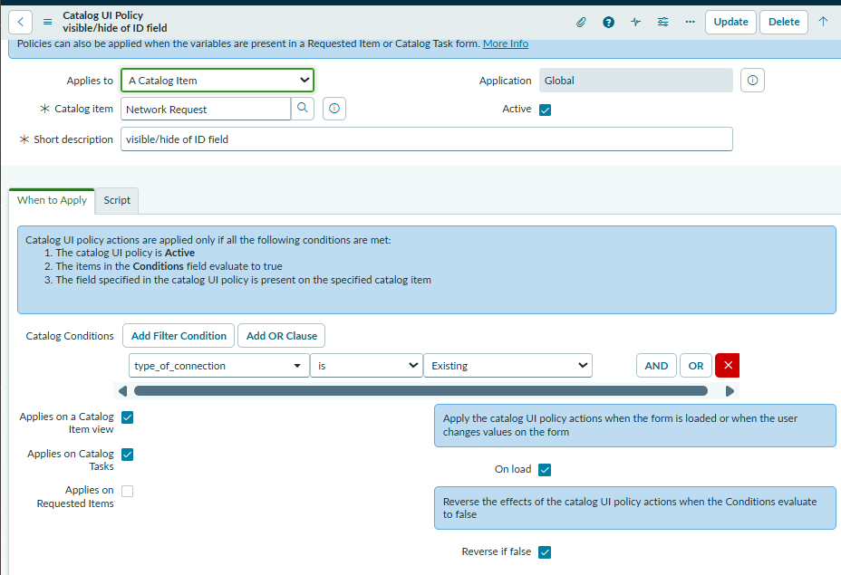
Step:3.4 Automation
Activity 1. Creation of Flow
Navigate to Flow designer home page
Click on New to create a new flow
Provide flow name as Network Request
Provide description of flow
Click on Build flow.
Activity 2. Configuring Trigger
Click on (+) Icon to Configure the Trigger
Select Trigger as Application >> Service catalog
Click on Done.
Activity 3. Configuring Actions
Click on Actions button to configure new action
Get Catalog Variables
● Click on Action, search for Get Catalog Variables
● Select Get Catalog Variables
● Action Inputs>> Trigger>>service catalog>>Requested Item
● Template catalog items >> Select table >> Network Request
● Select the Required Variables and Move to the selected area.
● Click on done
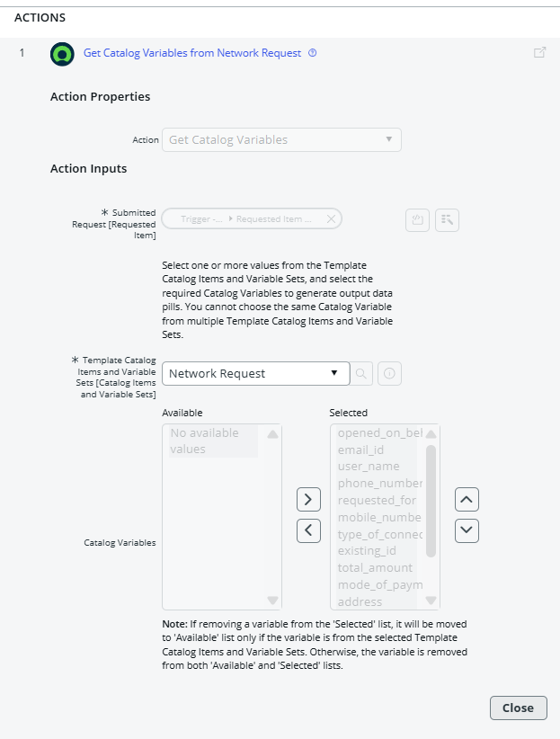

Create Record
● Select action as Create Record
● Select table as Database tables
● Click on Add fields button to configure the fields
● Configure the Required fields as shown in the below picture
● Click on done
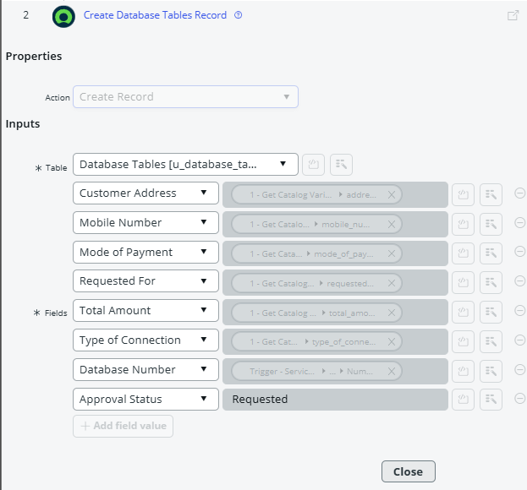
Send Email
● Select action as Send Email
● Select target record >> Create record>> database tables
● Table will be selected automatically
● Configure To, CC, BCC as per our requirements (select static/dynamic)
● Provide Subject & Body as shown in the below picture
● Click on done
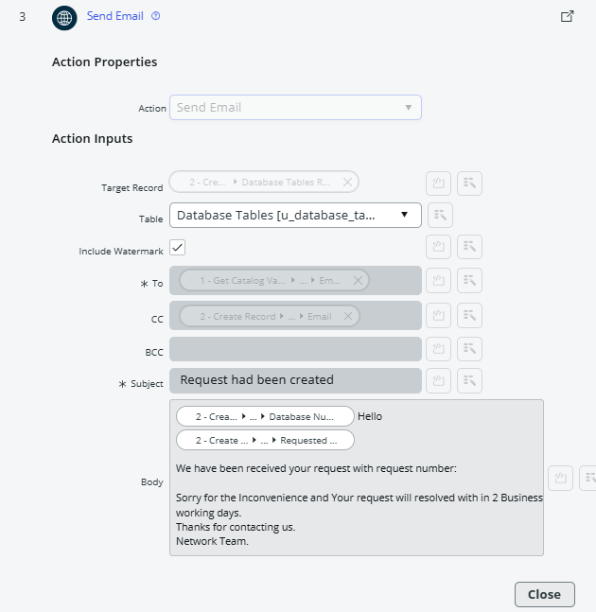
Ask for approvals
● Select action as Ask for Approval
● Select target record >> Create record>> database table
● Provide Approval Reason>> Waiting for approval
● Configure approval rules>> Approve, reject, approve/reject
● Select approvals as Anyone approves, everyone approves etc.
● We can select approvals like static/dynamic as shown below
● Click on done
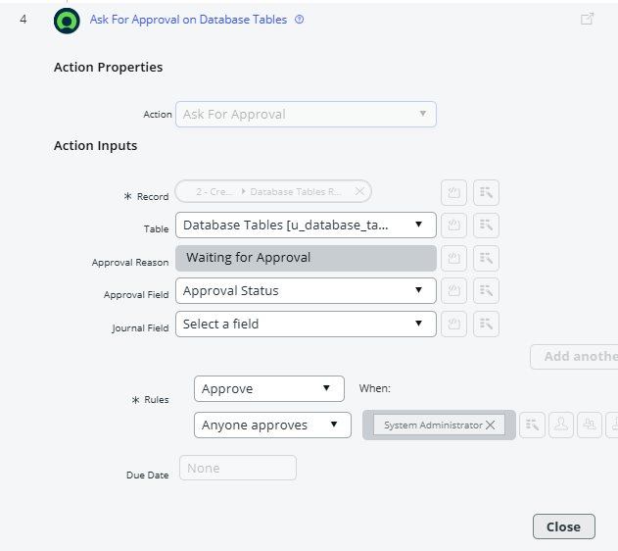
Flow Logic
● Select action as flow logic and Select If condition
● Apply condition >> Ask for approvals state is Approved/Rejected as per requirement
● Click on done
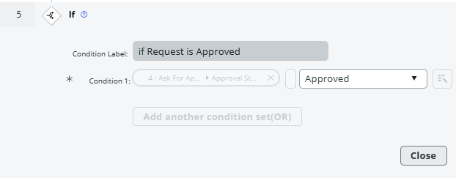
Update Record
● Select action as Update Record
● Select record as >> create record>> database tables
● Table will be selected automatically
● Configure the fields as per requirement, as shown in below
● Click on done
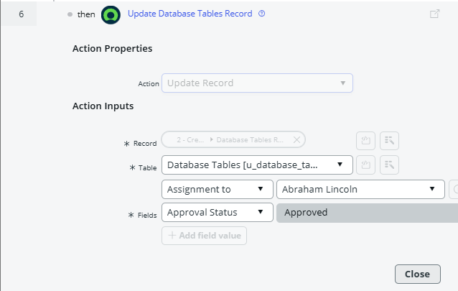

Flow Logic(Else)
● Select action as flow logic and Select Else condition
● In this Else condition select Update record as shown below
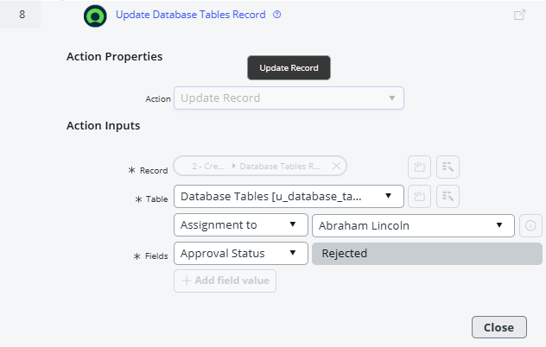

Note: Configure the actions and Logics as shown in the flow chart.
Full Flow Chart
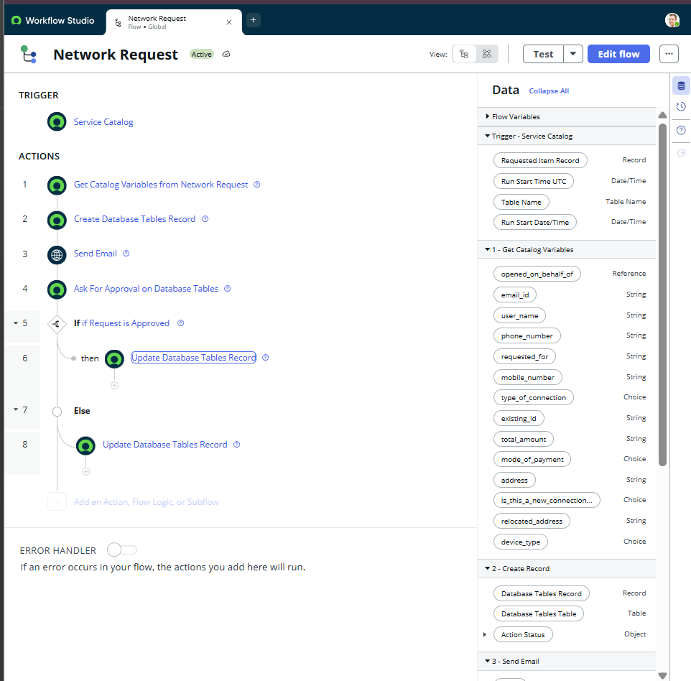
ACTIVATE it .
Then the page appear like this

Step :3.2 Navigation Flow
Procedure:
Login to ServiceNow PDI
Copy the Instance domain ex: https://dev190678.service-now.com.
Paste the URL in the Next tab and add Prefix SP to the URL. ex: https://dev190678.service-now.com/sp.
Search for Network Requests.
Fill the required details and click on submit
New Requests will be generated with request numbers and users will get particular emails on the same.
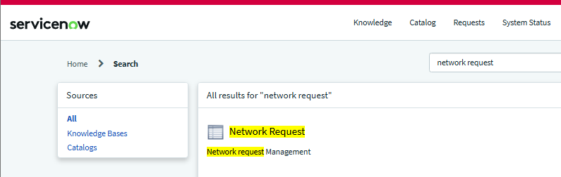
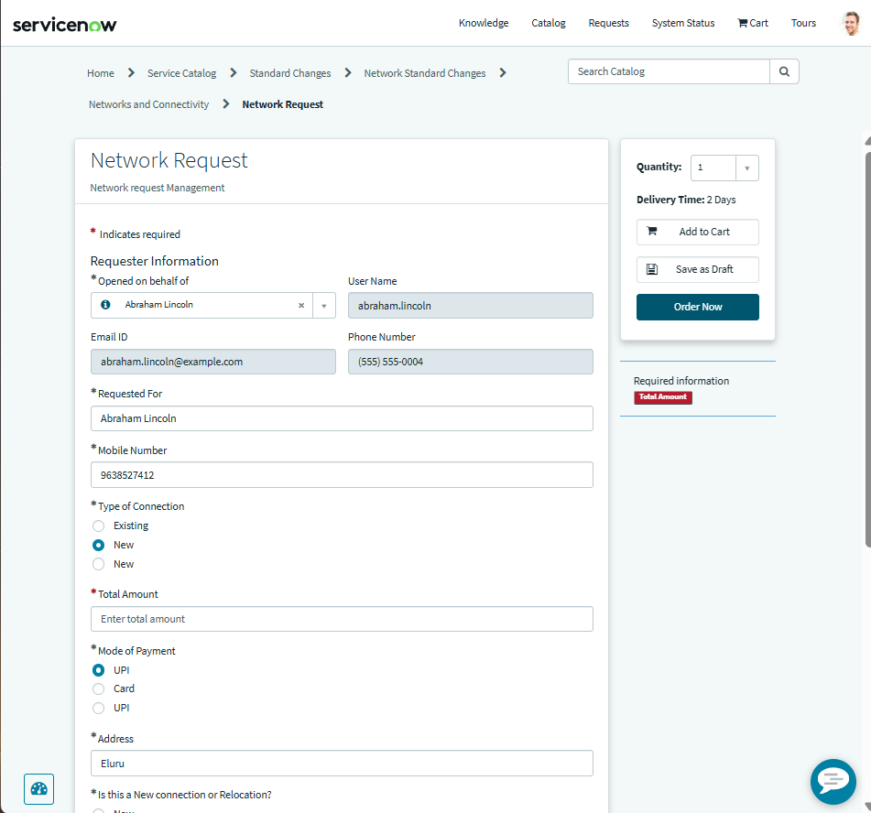
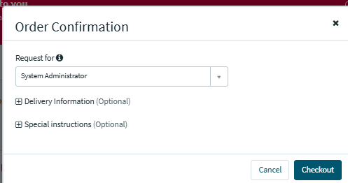
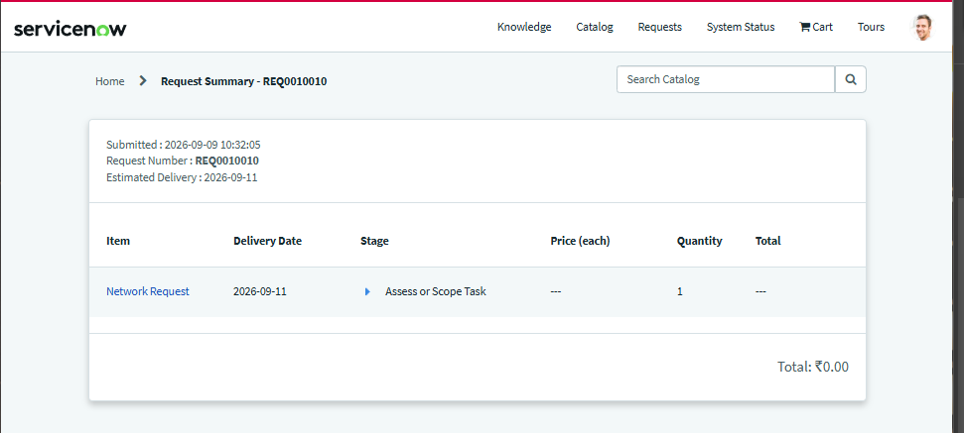
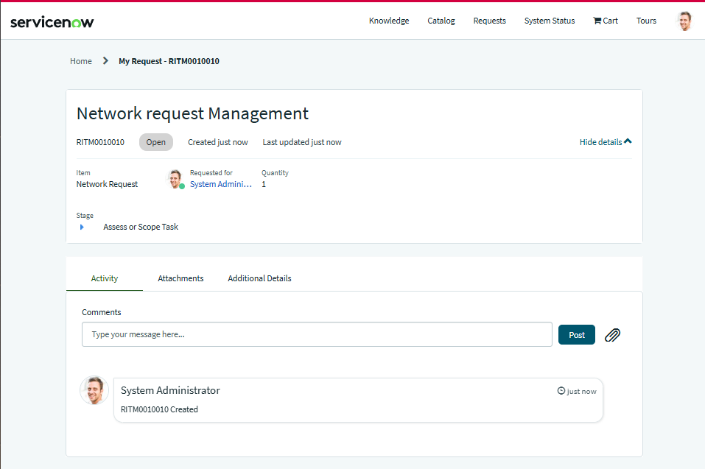
Copy the request number ex: RITM0010010
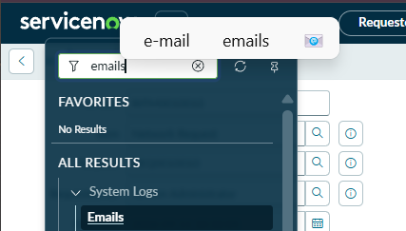
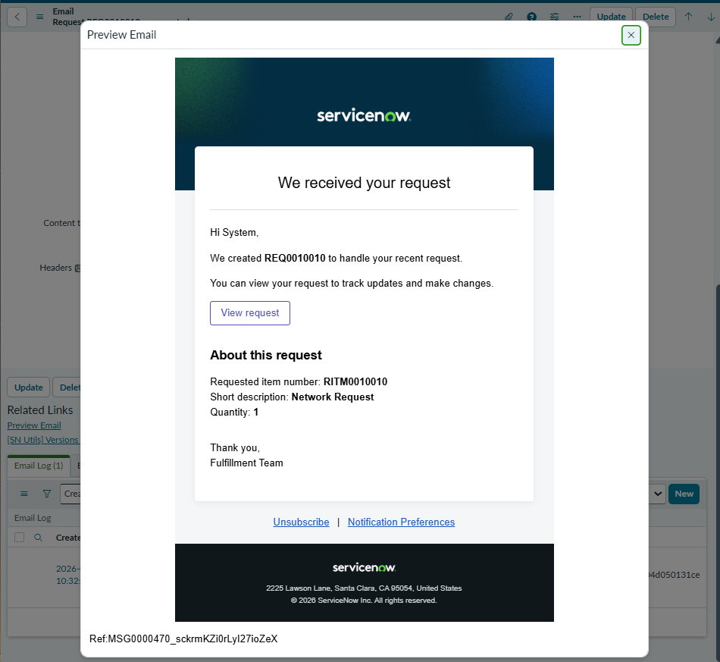
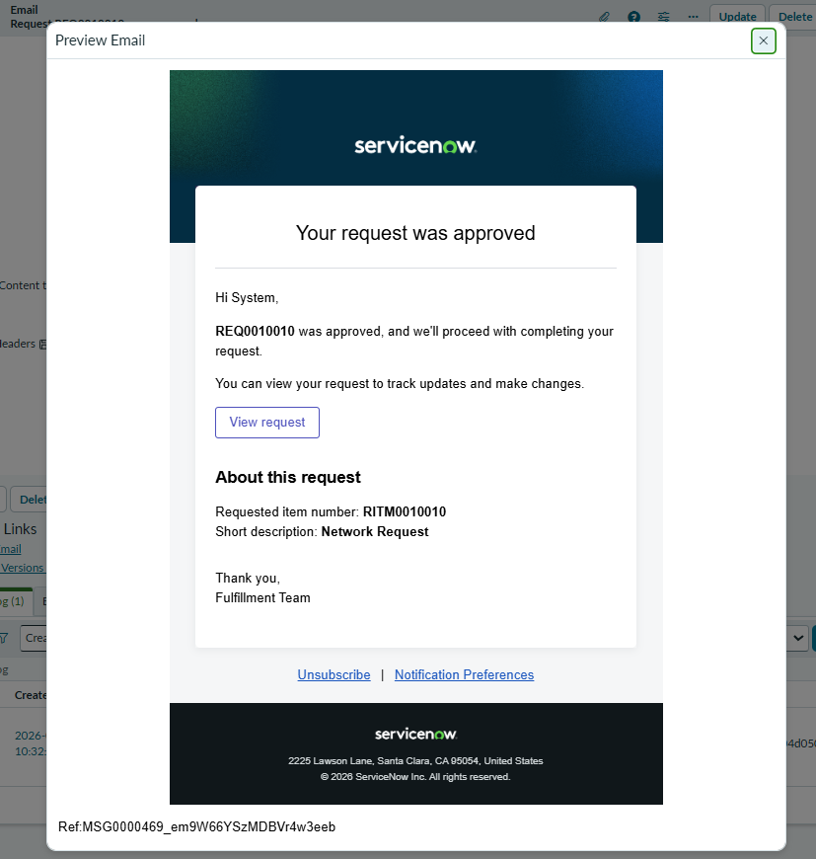
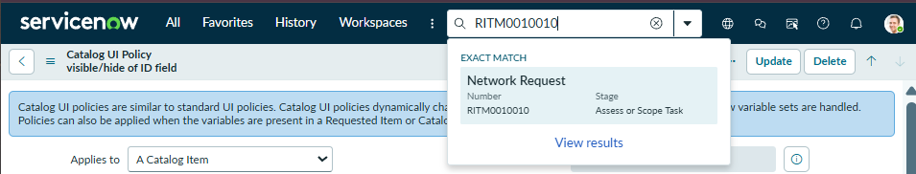
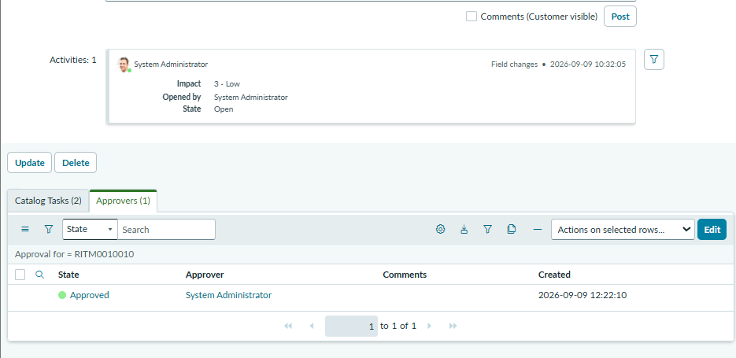
UPDATE
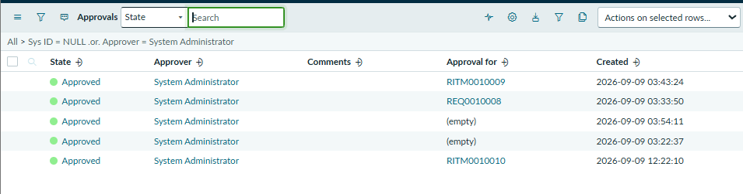
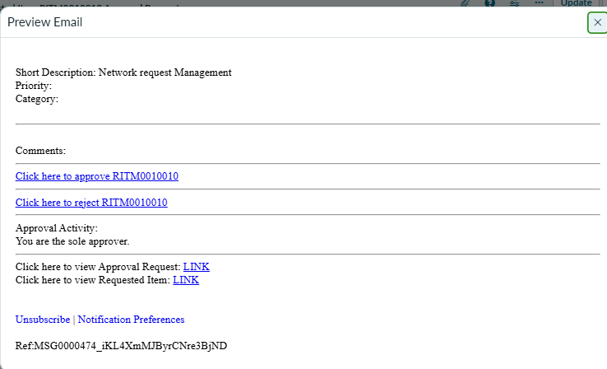
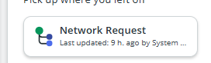
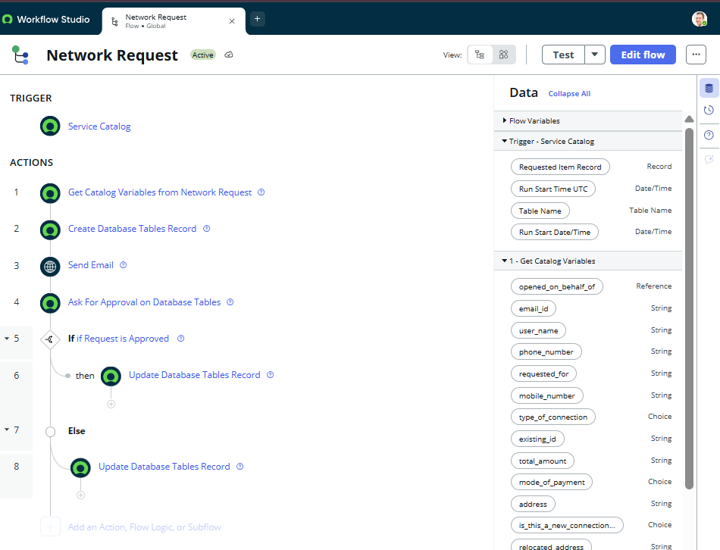
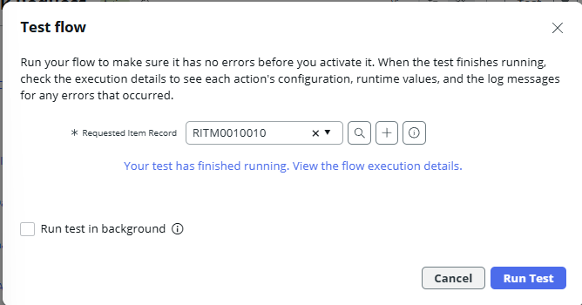
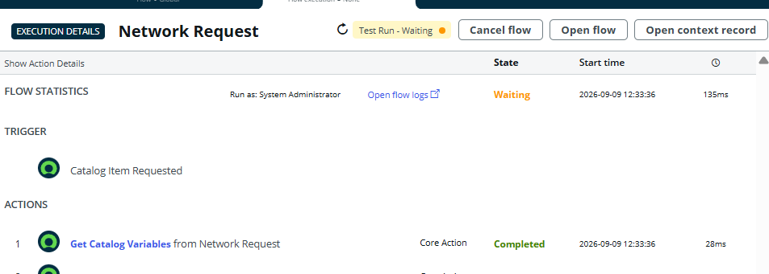
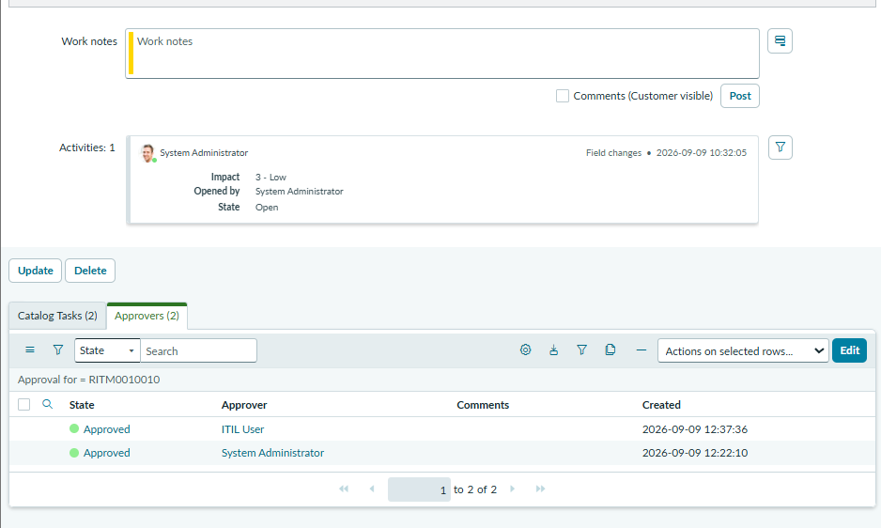
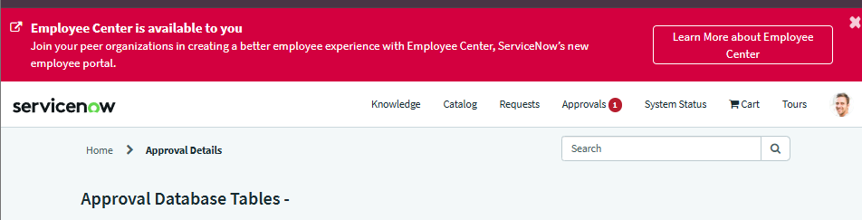
Click on approvals
Approve it.

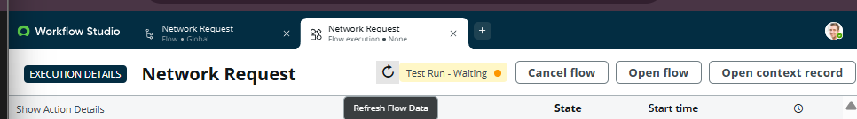
Test run
